2.26

Fut opens +0.6% prem.

US fut flat at 2745.

China amended constitution on Sunday which abolished max 2 terms for president.

Markets crashed in response.

Pnl swing AM: 140k. (3.5% of ptf)

Volatility level (high to low, annualized), 32%.

Market nervousness: 7/10

Desired pnl swing: under 1% of total capital.

Current delta: 7mm, desired delta: 2mm.

CYB and big stocks are perfectly negatively correlated.

**Musings:**

Delta was too big this month.

Problems:

1. Causing stress
2. Cannot take advantage of potential opportunities
3. Cannot hedge
4. Portfolio drawdown too big (20%)
5. Portfolio intraday vol too big (3%)
6. Cannot do inventory trading.
7. Your business cannot undertake risk that is greater than your capital. Have to be more conservative to survive.

The correct usage of futures

1. Inventory trading
2. PD trading
3. Hedge (due to ability to both long/short and cheaper transaction cost)

Incorrect usage:

1. Speculate with leverage (direction betting)

Going forward:

1. Trend delta not exceeding 1/3 total assets

When to hedge:

1. When markets open up/down a lot
2. When market volatility picks up.
3. When the US starts to have big moves.
4. When vol moves up.
5. High volatility is serially correlated, when vol goes up, don’t participate

A50 Vol term structure:

25/22/21 (for 2 days, 1 month, 4 months)

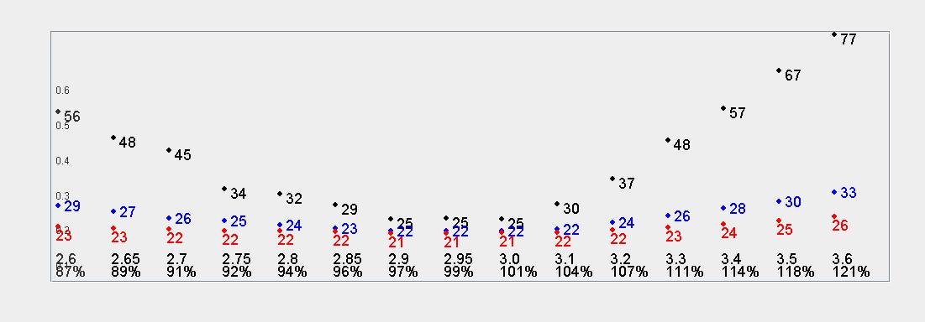

2.27.2018

Futs expire today. Challenging month.

**Problems**

1. Too much emphasis on buy and hold pnl on futures. This is a mistake.
2. Heavy position. Vulnerable to huge market swings.
3. Index underperforms the world in the long run.

**Going forward on Futures:**

1. No taking views on market
2. Focus on hedging stock ptf.
3. Cap pure trend delta to under 1/3.
4. Better prepare for crash scenarios.
5. Eager to disseminate.
6. Perishable goods inventory model -> acquire position, if no profit don’t add, if profit then sell.
7. Take advantage of day to day price swings.
8. Avoid being trapped in a trend, either up or down.
9. Careful of vol increases. Keep track of implied vol movements.
10. US vol spike -> hedge. China vol spike -> hedge. Intraday swing is high -> hedge.
11. Compare HO and LO as an indicator of real strength.
12. Discount/prem trading.

2.28.2018

Trading plan

1. fut expired ytd. Takes off 4mm delta. 3mm delta remaining. 800k is leverage.
2. US down 1%. VIX @ 18.6%.
3. Front month vol of vol 111% -> 132% (high 165 on 2/8).
4. Cut leverage on the stock side.
5. Stock: reduce to 2/3 position, about 1.5mm.
6. Fut: trade when vol is down to 12v + vol of vol goes down.
7. Fut do PMCL. No overnight holding.
8. Fut max position 1/3. (8 units)

VIX starts at 2:15CT (3:15 EST, 16:15 HKT)

Last month ended with 5 fut and this month ended with 48 fut. This shows the tendency for the position to go up when markets are good.

You need to set a maximum position size allowed which can limit destructive risk taking behavior.

Limit to 1/3 for now.

VIX Futures trading time (extended)

17pm chicago time (7am HKT)

**After market for this month:**

1. High vol environment persists, Cut out leverage
2. Never use leverage going forward.
3. Fut size: never exceed 1/3. Keep cash available. Be versatile. Take advantage of market opportunities.
4. You can only be risk neutral when size is small.
5. Long run stock ptf size < 1/3. Otherwise too much stress.
6. Morning cut delta: results not clear.
7. Still do pmcl.
8. Keep lessons of LTCM in mind. Genius with leverage fail. Never use leverage.

**3.1**

Pre open: High vol environment.

VIX: 19.85% (+6%)

Vol: SPX: 15%, NQ: 20%,

Vol of vol: 130% -> 140%

Sentiment: US panicked into the close. Market sentiment is weak. Vol started to pick up again. ETFs are indicating 1~1.5% drop.

Trading plan:

During bear market, bullish candles are surrounded by more bearish candles. When you have a bullish day, you should short to hedge the next.

Ytd market was down, today shorting won’t yield much advantage. PMCO was +0.3% last day, shcomp closed at 50% percentile. Not much trading advantage.

Stocks: goal until the end of this month: cut all leverage and migrate back to the normal account. Reduce to 1/3 position by the end of April.

High vol environment: low delta. Eager hedging. You should hedge OPC as well as AM and only leave exposure for pmcl autocorr. To limit risk on futures overnight, you should have lower stock position to hedge. Both at 1/3 would be optimal.

VIX needs to go back to 10% to validate the continuation of the bull market. Now VIX is at 20%. The short vol houses will need to buy back vol and delta.

3.2

942am

Shanghai50 ETF:

Mar 22 -> 25v.

Apr 23->24

Jun 21 -> 22

Sep Unch @ 22.

Upside strikes up 2v

Downside up 1v.

Index opened down by 0.8%. A50 fut down 1% overnight.

H.S.I v back to 25v.

HSCEI: 28.3%.

1036:

Markets started recovering – march atm to 24 vol.

1105

Vols continue to drop to 22 v.

China is performing stronger than than Asia.

1331

Skew came off. -25D put came off 1v. 25D vol unchanged.

3.3

Pre market:

1. US rebounds on Friday 3/2
2. VIX back to 19.6.
3. SPX skew came off as put vol was better offered.
4. NDX vols 24 -> 21.
5. NDX 25D skew : 5v
6. VoV 150 -> 130
7. VHSI @ 25.
8. H.S.I vol averaged 15 in 2017 (bull market)
9. H.S.i vol was never below 18 from 2015.4 to 2016.1 (china 3 crashes)
10. When vol is high like this, position down to 1/3. Trade conservatively.

This week:

1. Started to refocus on vol
2. Use vol to decide position sizing
3. Back to high vol regime – lower position
4. Strategy has formed: keep long position in quality stocks with earnings
5. Use futures to hedge / play pmcl.
6. Hedge with futures when previous pm is up / close at a high percentile.
7. Low vol regime max delta : 2/3.
8. High vol max delta : 1/3.